Disguise Browser as a Google Bot.
- Install Mozilla Firefox on your computer systems.

- Go to the website https://www.whatismybrowser.com/ & the below should be the Output.

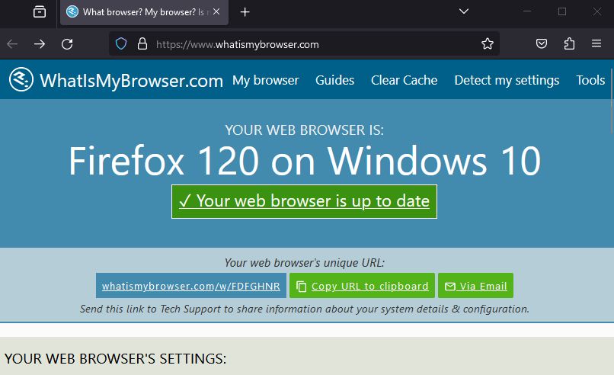

- Open this link in Google crome
Get the Google Bot useragent string from the below website & copy the Google Bot Useragent String. https://useragentstring.com/Googlebot2.1_id_71.php

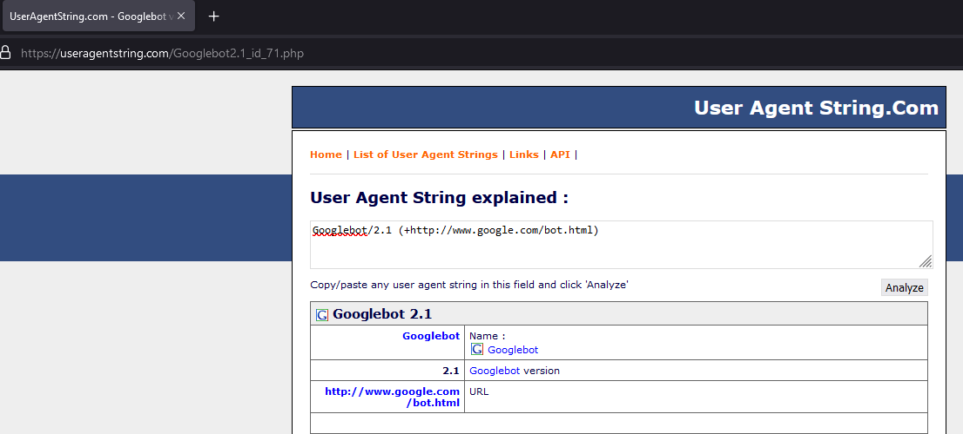

- The Google Bot User Agent String will be
Googlebot/2.1 (+http://www.google.com/bot.html)

- On your firefox, type the following in the address bar about:config this will open the Browser Configuration Pane.

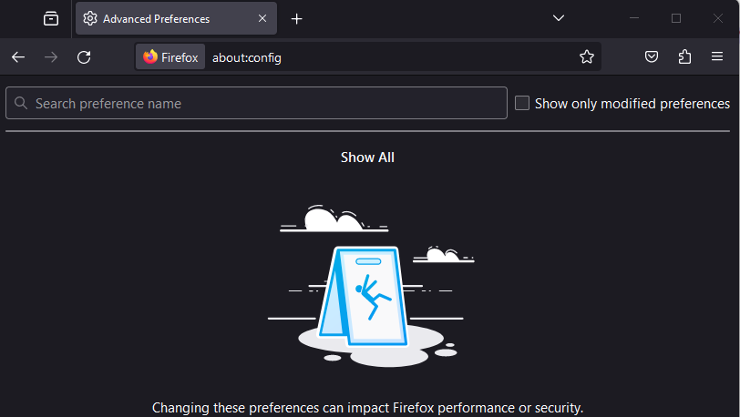

- In the search preference name text box, type the below
general.useragent.override , click on string , click on “ + “ icon input the google bot Agent String.

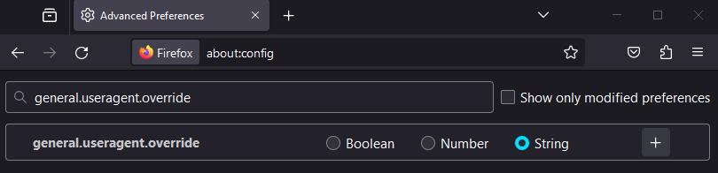
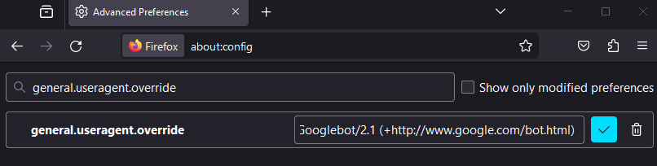
One added, click on the tick Button to save the value.
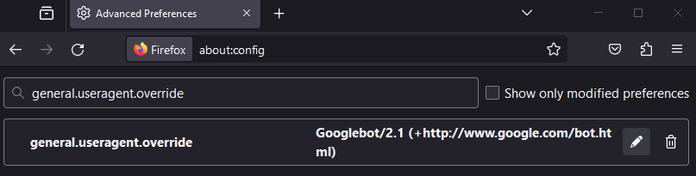

7. Again go to the site https://www.whatismybrowser.com/ & check the output, the value of Firefox will be changed to Google Bot.
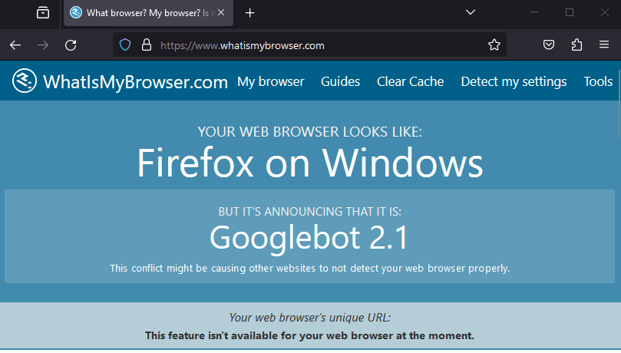

8.Bonus : change the Value of general.useragent.override to anything that you want.
The Browser will announce that name.

